**Discrete Mathematical Structures**

**Week-7**

**Long Descriptive Questions**

**1,** **Give a brief note on the all special types of graphs**

Complete Graph

A simple graph G is said to be complete if every vertex in G is connected with every other vertex. i.e., if G contains exactly one edge between each pair of distinct vertices. The complete graph on n vertices is denoted by Kn.

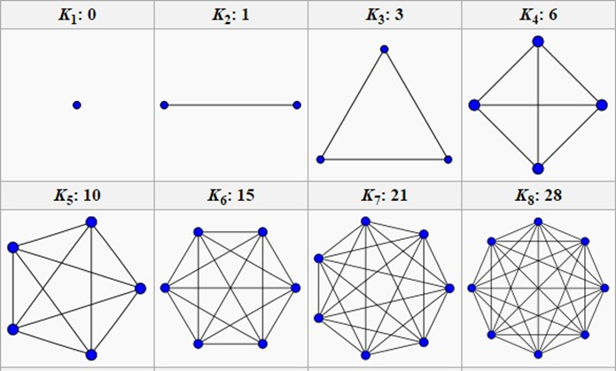

Note

* The symbol K is used in honor of the Polish Mathematician Ku-ratowski.
* The complete graph on five vertices is referred to as KuratowskiŠs first graph.
* The number of edges in Kn is nC2 or Hence, the maximum number of edges in a simple graph with n vertices is
* Complete graphs are used in modelling round-robin tournaments. Round-robin tournaments are those in which every team plays exactly once with every other team. The teams are taken as vertices of the complete graph

Regular graph

If every vertex of a simple graph has the same degree, then the graph is called a regular graph. If every vertex in a regular graph has degree k, then the graph is called k-regular.

Note

* Any complete graph is regular but the converse is not true.

Examples of regular graphs which are not complete

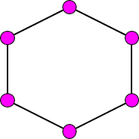 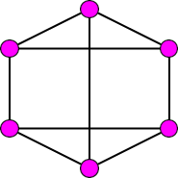 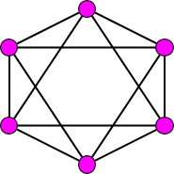

2 − regular 3 − regular 4 – regular

Cycle The cycle Cn, n ≥ 3, consists of n vertices v1, v2, . . . , vn and edges {v1, v2}, {v2, v3}, ......, {vn1, vn}, and {vn, v1}.

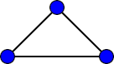 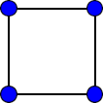 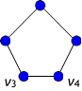 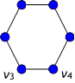

C3 C4 C5 C6

Note

* If the degree of every vertex of a simple graph is of degree 2 then it is called a cycle. Cycle is a 2 regular graph.

Bipartite graph

A graph G = (V, E) is bipartite if the vertex set V can be partitioned into two subsets (disjoint) V1 and V2 such that every edge in E connects a vertex in V1 and a vertex V2 (so that no edge in G connects either two vertices in V1 or two vertices in V2 ). (V1, V2) is called a bipartition of G.

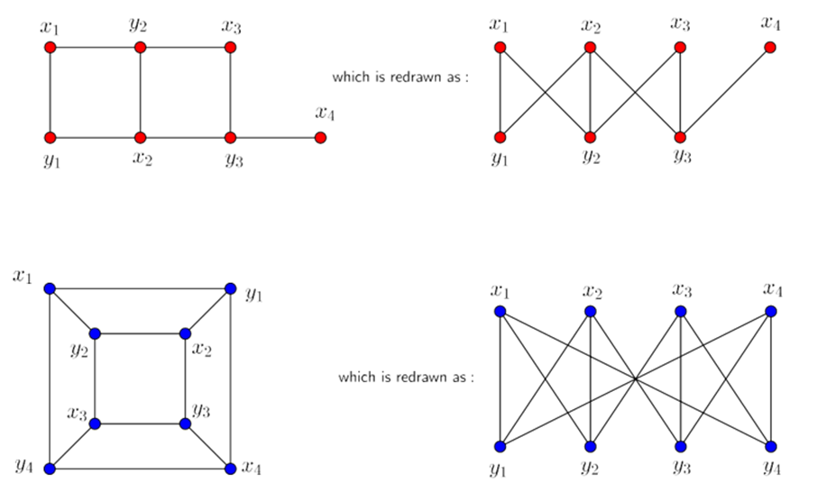

Note

* Obviously, a bipartite graph can have no loop.
* From the definition it is clear that no edge contains two vertices of V1 or two vertices of V2. . Clearly no two vertices of V1 or V2 are adja-cent.
* The pair (V1, V2) is called a bipartition of V3. A bipartite graph is also known as bigraph.

Is C6 is bipartite?

C6 is a bipartite graph as shown in Figure above. Since its vertex set can be partitioned into two sets V1 = {v1, v3, v5} and V2 = {v2, v4, v6} and every edge of C6 connects a vertex in V1 and a vertex in V2.

Is C3 or K3 is bipartite?

C3 is a not a bipartite graph as shown in Figure above. The vertex set V ={v1, v2, v3} cannot be partitioned into disjoint sets as any pair of vertices taken is adjacent.

Complete bipartite graph

If each vertex of V1 is connected with every vertex of V2 by an edge, then G is called a completely bipartite graph. If V1 contains m vertices and V2 contains n vertices, then the com-plete bipartite graph is denoted by Km,n

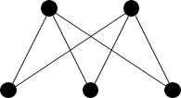 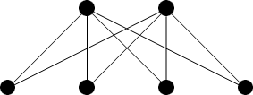

K2,3 K2,4

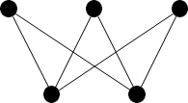 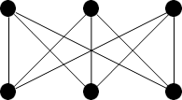

K3,2 K3,3

* The number of vertices is m + n.
* The number of edges is m × n.
* The complete bipartite graph K3,3 is called Kuratowski’s second graph.
* Km,n is not regular if m /= n.

**2, Draw all possible graphs on 5 vertices and count the number of bipartite, regular and complete graphs in it**

There are 6 possible graphs on 5 vertices.

* The null graph, which has no edges and only 5 isolated vertices



Null Graph

* The complete graph, denoted K5, which has all 10 possible edges between the 5 vertices.

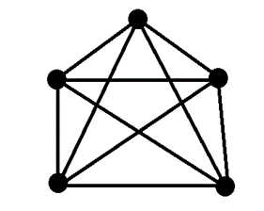

K5 Graph

* The cycle graph, denoted C5, which has 5 vertices arranged in a circular fashion with each vertex connected to its two neighbors

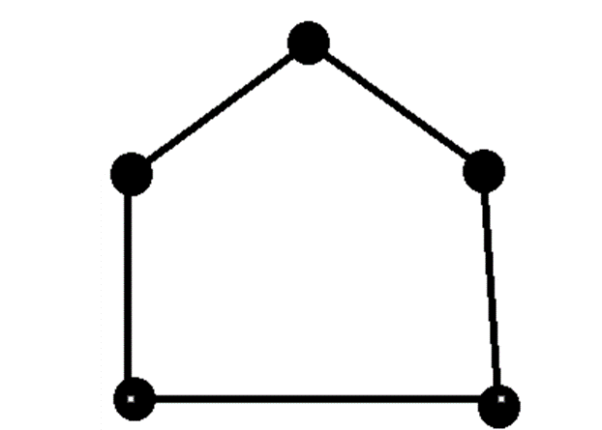

C5 Graph

* The path graph, denoted P5, which has 5 vertices arranged in a line with each vertex connected to its two adjacent vertices



* The star graph, denoted S5, which has one central vertex con-nected to all 4 other vertices, which are not connected to each other

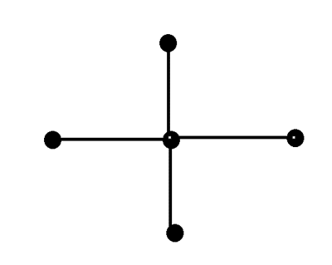

Star Graph

* The bipartite graph, which has two disjoint sets of vertices with edges only between vertices in different sets. There are two non-isomorphic bipartite graphs on 5 vertices: the complete bipartite graph K2,3 and the empty bipartite graph K1,4. 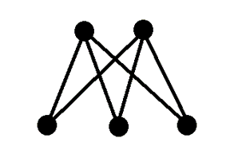 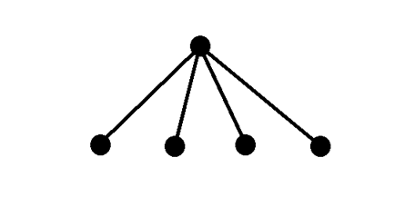

K2,3 K1,4

**3,** **Does there exists a 4-regular graph on 6 vertices? If so construct a graph**

It has six vertices as well as degree of each vertices are same for each vertex, which is 4. So it is a 4-regular graph on 6 vertices

